|  |
| --- |
| Question 01. |

package Question01.ArrayBased;

public class **Functions** {

List list01 = new List(10);

public Functions(int[] numberList) {

for (int i: numberList) {

list01.insertLast(i);

}

}

int Sum(){

int sum = 0;

for(int j=0 ; j<list01.listSize(); j++){

sum+= list01.retrieveList(j);

}

return sum;

}

double Avg(){

return (double) Sum()/list01.listSize();

}

int Max(){

int max=Integer.MIN_VALUE;

for (int i = 0; i <list01.listSize(); i++) {

if (max<= list01.retrieveList(i))

max = list01.retrieveList(i);

}

return max;

}

int Min(){

int min=Integer.MAX_VALUE;

for (int i = 0; i <list01.listSize(); i++) {

if (min>= list01.retrieveList(i))

min = list01.retrieveList(i);

}

return min;

}

int EvvenCount(){

int count=0;

for (int i = 0; i <list01.listSize(); i++) {

if (list01.retrieveList(i)%2==0)

count++;

}

return count;

}

}

package Question01.ArrayBased;

public class **Test** {

public static void main(String[] args) {

Functions functions = new Functions(new int[]{15, 22, 7, 13, 8, 6, 19, 20, 4, 17});

System.out.println("Sum: "+functions.Sum());

System.out.println("Average: "+functions.Avg());

System.out.println("Max: "+functions.Max());

System.out.println("Min: "+functions.Min());

System.out.println("Count of Evens: "+functions.EvvenCount());

}

}

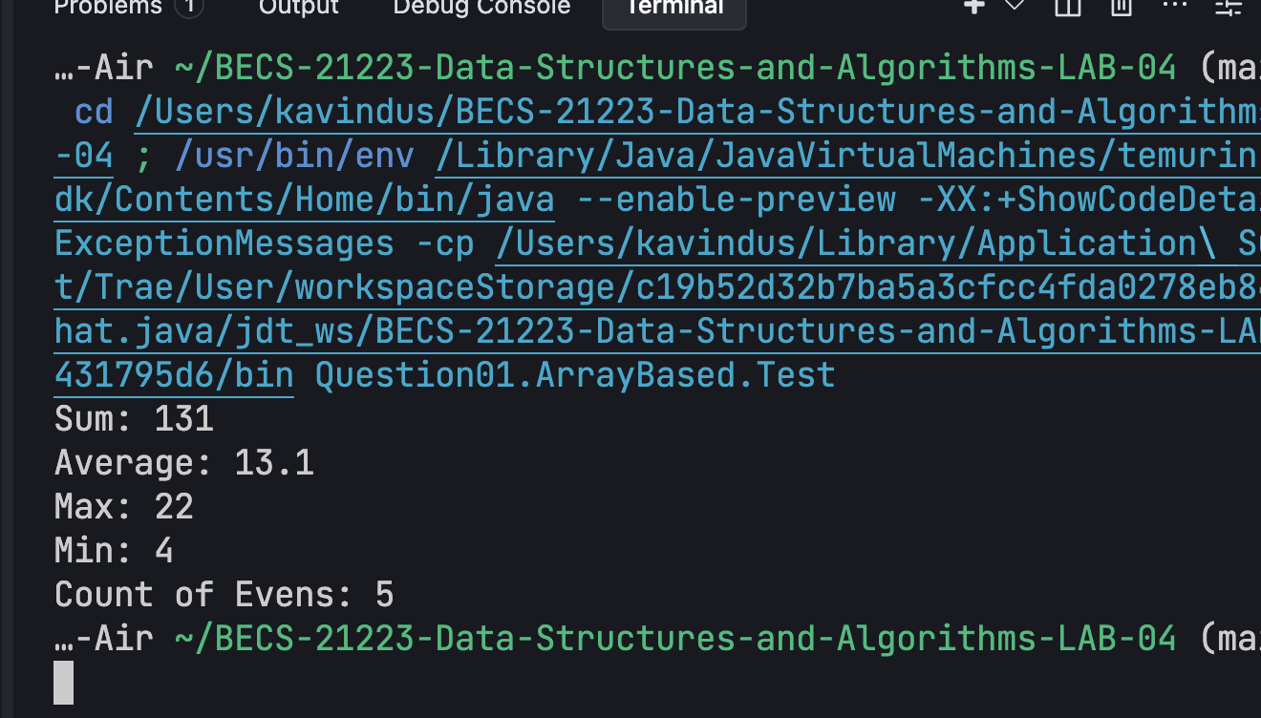

package Question01.ArrayBased;

public class **List** {

private int maxSize;

private int position;

private int[] listEntry;

public List(int size) {

maxSize = size;

listEntry = new int[maxSize];

position = -1;

}

boolean isListEmpty() {

return position == -1;

}

boolean isListFull() {

return position == maxSize - 1;

}

int listSize() {

return position + 1;

}

void insertLast(int x) {

if (isListFull())

System.out.println("Attempt to insert at the end of a full list");

else

listEntry[++position] = x;

}

void insertList(int p, int element) {

if (isListFull())

System.out.println("Attempt to insert into a full list");

else if (p < 0 || p > listSize())

System.out.println("Invalid position for insertion");

else {

for (int i = position; i > p; i--)

listEntry[i] = listEntry[i-1];

listEntry[p] = element;

position++;

}

}

int deleteList(int p) {

int element;

if (isListEmpty()) {

System.out.println("Attempt to delete from an empty list");

return 0;

} else if (p < 0 || p >= listSize()) {

System.out.println("Invalid position for deletion");

return 0;

} else {

element = listEntry[p];

for (int i = p; i < position; i++)

listEntry[i] = listEntry[i+1];

position--;

return element;

}

}

int retrieveList(int p) {

if (isListEmpty()) {

System.out.println("Attempt to retrieve from an empty list");

return 0;

} else if (p < 0 || p >= listSize()) {

System.out.println("Invalid position for retrieval");

return 0;

} else {

return listEntry[p];

}

}

void replaceList(int p, int x) {

if (isListEmpty()) {

System.out.println("Attempt to replace in an empty list");

} else if (p < 0 || p >= listSize()) {

System.out.println("Invalid position for replacement");

} else {

listEntry[p] = x;

}

}

void traverseList() {

for (int i = 0; i <= position; i++)

System.out.println(listEntry[i]);

}

}

|  |
| --- |
| Question 02. |

package Question02.ArrayBased.Primitive;

import java.util.ArrayList;

import java.util.Arrays;

public class **Functions** {

List ballList = new List(6);

List scoreList = new List(6);

ArrayList<String> nameList = new ArrayList<String>();

public Functions(String[] NameList,int[] BallList,int[] ScoreList) {

for (int i: BallList) {

ballList.insertLast(i);

}

for (int i: ScoreList) {

scoreList.insertLast(i);

}

for (String j : NameList

) {

this.nameList.add(j);

}

}

public String HighestScorePlayer(){

int pointer = 0;

int maxScore = Integer.MIN_VALUE;

for (int i = 0; i < scoreList.listSize(); i++) {

if (maxScore<=scoreList.retrieveList(i)){

maxScore = scoreList.retrieveList(i);

pointer = i;

}

}

return nameList.get(pointer);

}

public String LowestNumberOfBalls(){

int pointer = 0;

int lowBalls = Integer.MAX_VALUE;

for (int i = 0; i < ballList.listSize(); i++) {

if (lowBalls>=scoreList.retrieveList(i)){

lowBalls = scoreList.retrieveList(i);

pointer = i;

}

}

return nameList.get(pointer);

}

int BattingPointer ;

public void displayBattingStrike(){

double HighbattingStrikeRate = 0;

double Pointer = 0;

for (int i = 0; i < ballList.listSize(); i++) {

double currentStrikerate = calculateStrikeRate(scoreList.retrieveList(i), ballList.retrieveList(i));

System.out.printf("Player "+nameList.get(i)+ " : %.2f\n", currentStrikerate);

if (HighbattingStrikeRate <= currentStrikerate){

HighbattingStrikeRate = currentStrikerate;

Pointer = i;

}

this.BattingPointer = (int) Pointer;

}

}

public String ManOfTheMatch(){

return nameList.get(BattingPointer);

}

public static double calculateStrikeRate(int battingScore, int ballsFaced) {

if (ballsFaced == 0) {

System.out.println("Error: Balls faced cannot be zero.");

return 0.0;

}

return (double) battingScore * 100 / ballsFaced;

}

}

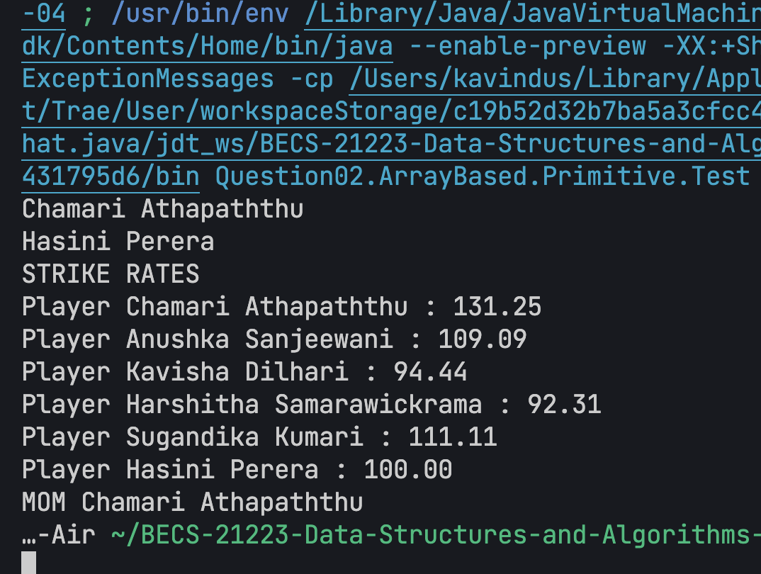

package Question02.ArrayBased.Primitive;

public class **Test** {

public static void main(String[] args) {

Functions functions = new Functions(

new String[] {

"Chamari Athapaththu",

"Anushka Sanjeewani",

"Kavisha Dilhari",

"Harshitha Samarawickrama",

"Sugandika Kumari",

"Hasini Perera"

},new int[] {48, 22, 18, 13, 9, 3},

new int[] {63, 24, 17, 12, 10, 3}

);

// nama, bola, lakunu danna

System.out.println(functions.HighestScorePlayer());

System.out.println(functions.LowestNumberOfBalls());

System.out.println("STRIKE RATES");

functions.displayBattingStrike();

System.out.println("MOM "+functions.ManOfTheMatch());

}

}

package Question02.ArrayBased.Primitive;

public class **List** {

private int maxSize;

private int position;

private int[] listEntry;

public List(int size) {

maxSize = size;

listEntry = new int[maxSize];

position = -1;

}

boolean isListEmpty() {

return position == -1;

}

boolean isListFull() {

return position == maxSize - 1;

}

int listSize() {

return position + 1;

}

void insertLast(int x) {

if (isListFull())

System.out.println("Attempt to insert at the end of a full list");

else

listEntry[++position] = x;

}

void insertList(int p, int element) {

if (isListFull())

System.out.println("Attempt to insert into a full list");

else if (p < 0 || p > listSize())

System.out.println("Invalid position for insertion");

else {

for (int i = position; i > p; i--)

listEntry[i] = listEntry[i-1];

listEntry[p] = element;

position++;

}

}

int deleteList(int p) {

int element;

if (isListEmpty()) {

System.out.println("Attempt to delete from an empty list");

return 0;

} else if (p < 0 || p >= listSize()) {

System.out.println("Invalid position for deletion");

return 0;

} else {

element = listEntry[p];

for (int i = p; i < position; i++)

listEntry[i] = listEntry[i+1];

position--;

return element;

}

}

int retrieveList(int p) {

if (isListEmpty()) {

System.out.println("Attempt to retrieve from an empty list");

return 0;

} else if (p < 0 || p >= listSize()) {

System.out.println("Invalid position for retrieval");

return 0;

} else {

return listEntry[p];

}

}

void replaceList(int p, int x) {

if (isListEmpty()) {

System.out.println("Attempt to replace in an empty list");

} else if (p < 0 || p >= listSize()) {

System.out.println("Invalid position for replacement");

} else {

listEntry[p] = x;

}

}

void traverseList() {

for (int i = 0; i <= position; i++)

System.out.println(listEntry[i]);

}

}

|  |
| --- |
| Question 03. |

package Question03;

public class **Functions** {

private List partyList;

public Functions(List partyList) {

this.partyList = partyList;

}

public void findWinningPartiesPerDistrict() {

if (partyList.isListEmpty()) {

System.out.println("No party data available.");

return;

}

String[] districts = {"Gampaha", "Colombo", "Kalutara"};

for (int i = 0; i < districts.length; i++) {

Party winner = null;

int maxVotes = -1;

for (int j = 0; j < partyList.listSize(); j++) {

Party currentParty = partyList.retrieveList(j);

int currentVotes = 0;

if (i == 0) currentVotes = currentParty.getGampahaVotes();

else if (i == 1) currentVotes = currentParty.getColomboVotes();

else currentVotes = currentParty.getKalutaraVotes();

if (currentVotes > maxVotes) {

maxVotes = currentVotes;

winner = currentParty;

}

}

if (winner != null) {

System.out.println("Winning party in " + districts[i] + ": " + winner.getName() + " (" + maxVotes + " votes)");

}

}

}

public void findOverallWinner() {

if (partyList.isListEmpty()) {

System.out.println("No party data available.");

return;

}

Party overallWinner = null;

int maxTotalVotes = -1;

for (int i = 0; i < partyList.listSize(); i++) {

Party currentParty = partyList.retrieveList(i);

if (currentParty.getTotalVotes() > maxTotalVotes) {

maxTotalVotes = currentParty.getTotalVotes();

overallWinner = currentParty;

}

}

if (overallWinner != null) {

System.out.println("Overall Provincial Election Winner: " + overallWinner.getName() + " (" + maxTotalVotes + " total votes)");

}

}

public void findMinVotesPerDistrict() {

if (partyList.isListEmpty()) {

System.out.println("No party data available.");

return;

}

String[] districts = {"Gampaha", "Colombo", "Kalutara"};

for (int i = 0; i < districts.length; i++) {

Party loser = null;

int minVotes = Integer.MAX_VALUE;

for (int j = 0; j < partyList.listSize(); j++) {

Party currentParty = partyList.retrieveList(j);

int currentVotes = 0;

if (i == 0) currentVotes = currentParty.getGampahaVotes();

else if (i == 1) currentVotes = currentParty.getColomboVotes();

else currentVotes = currentParty.getKalutaraVotes();

if (currentVotes < minVotes) {

minVotes = currentVotes;

loser = currentParty;

}

}

if (loser != null) {

System.out.println("Party with minimum votes in " + districts[i] + ": " + loser.getName() + " (" + minVotes + " votes)");

}

}

}

public void findEligibleParties() {

if (partyList.isListEmpty()) {

System.out.println("No party data available.");

return;

}

System.out.println("Eligible parties (more than 100,000 total votes):");

boolean found = false;

for (int i = 0; i < partyList.listSize(); i++) {

Party currentParty = partyList.retrieveList(i);

if (currentParty.getTotalVotes() > 100000) {

System.out.println("- " + currentParty.getName() + " (" + currentParty.getTotalVotes() + " total votes)");

found = true;

}

}

if (!found) {

System.out.println("No parties are eligible for a seat based on this criterion.");

}

}

}

package Question03;

public class **List** {

private int maxSize;

private int position;

private Party[] listEntry;

public List(int size) {

maxSize = size;

listEntry = new Party[maxSize];

position = -1;

}

boolean isListEmpty() {

return position == -1;

}

boolean isListFull() {

return position == maxSize - 1;

}

int listSize() {

return position + 1;

}

void insertLast(Party x) {

if (isListFull())

System.out.println("Attempt to insert at the end of a full list");

else

listEntry[++position] = x;

}

void insertList(int p, Party element) {

if (isListFull())

System.out.println("Attempt to insert into a full list");

else if (p < 0 || p > listSize())

System.out.println("Invalid position for insertion");

else {

for (int i = position; i >= p; i--) // Corrected loop condition

listEntry[i + 1] = listEntry[i];

listEntry[p] = element;

position++;

}

}

Party deleteList(int p) {

Party element;

if (isListEmpty()) {

System.out.println("Attempt to delete from an empty list");

return null;

} else if (p < 0 || p >= listSize()) {

System.out.println("Invalid position for deletion");

return null;

} else {

element = listEntry[p];

for (int i = p; i < position; i++)

listEntry[i] = listEntry[i + 1];

position--;

return element;

}

}

Party retrieveList(int p) {

if (isListEmpty()) {

System.out.println("Attempt to retrieve from an empty list");

return null;

} else if (p < 0 || p >= listSize()) {

System.out.println("Invalid position for retrieval");

return null;

} else {

return listEntry[p];

}

}

void replaceList(int p, Party x) {

if (isListEmpty()) {

System.out.println("Attempt to replace in an empty list");

} else if (p < 0 || p >= listSize()) {

System.out.println("Invalid position for replacement");

} else {

listEntry[p] = x;

}

}

void traverseList() {

for (int i = 0; i <= position; i++)

System.out.println(listEntry[i].toString());

}

}

package Question03;

public class **Party** {

private String name;

private int gampahaVotes;

private int colomboVotes;

private int kalutaraVotes;

public Party(String name, int gampahaVotes, int colomboVotes, int kalutaraVotes) {

this.name = name;

this.gampahaVotes = gampahaVotes;

this.colomboVotes = colomboVotes;

this.kalutaraVotes = kalutaraVotes;

}

public String getName() {

return name;

}

public int getGampahaVotes() {

return gampahaVotes;

}

public int getColomboVotes() {

return colomboVotes;

}

public int getKalutaraVotes() {

return kalutaraVotes;

}

public int getTotalVotes() {

return gampahaVotes + colomboVotes + kalutaraVotes;

}

public String toString() {

return "Party: " + name + ", Gampaha: " + gampahaVotes + ", Colombo: " + colomboVotes + ", Kalutara: " + kalutaraVotes + ", Total: " + getTotalVotes();

}

}

package Question03;

public class **Test** {

public static void main(String[] args) {

List electionData = new List(5);

electionData.insertLast(new Party("A", 12453, 89023, 60250));

electionData.insertLast(new Party("B", 23457, 41900, 35890));

electionData.insertLast(new Party("C", 74129, 23000, 56000));

electionData.insertLast(new Party("D", 202, 57, 354));

electionData.insertLast(new Party("E", 87, 5, 457));

Functions analysis = new Functions(electionData);

analysis.findWinningPartiesPerDistrict();

analysis.findOverallWinner();

analysis.findMinVotesPerDistrict();

analysis.findEligibleParties();

}

